Adjusting OWASP CRS Parameters
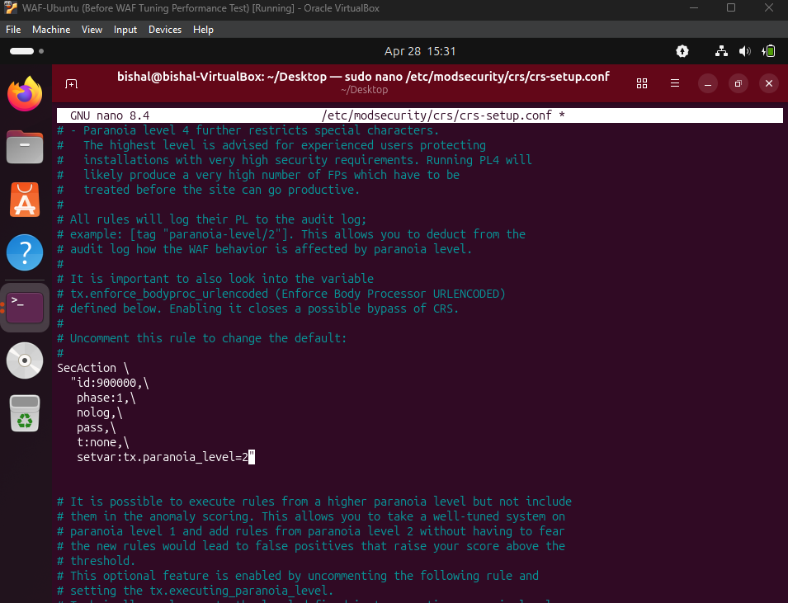

The OWASP CRS configuration was refined by enabling and setting the paranoia level to 2. This increased the strictness of request inspection and improved detection of malicious inputs.

Analysis
Performance testing was conducted using curl, ApacheBench (ab), and hey to evaluate the impact of ModSecurity on system performance.

Baseline results (WAF disabled) showed lower response times and higher throughput. When the WAF was enabled, response time increased slightly and requests per second decreased due to HTTP inspection and OWASP CRS rule processing.

Despite this overhead, the system remained stable and responsive, with no significant failures observed. This demonstrates that the WAF provides enhanced security with acceptable performance impact in a controlled environment.

